EXAMINATION PAPER
MEMMORANDUM
SUBJECT:  CHAMBER OF MINES OF SOUTH AFRICA: INTERMEDIATE CERTIFICATE IN MINE ENVIRONMENTAL CONTROL  PAPER 1  SUBJECT CODE: COMIMEC  EXAMINATION DATE: 11 may 2018  TIME: 14:30 – 17:30 | Examiner:  Johan Pienaar  Moderator: Inus Labuschagne  TOTAL MARKS: [100]  PASS MARK: [60%]

NUMBER OF PAGES: 10

SPECIAL REQUIREMENTS:
THIS IS NOT AN OPEN BOOK EXAMINATION. THERE IS NO FORMULA HANDOUT
INSTRUCTIONS TO CANDIDATES:
- Answer all questions legibly in English.
- Write your ID number on the outside cover of each book used and on any graph paper or other loose sheets handed in.
NB: Your name must not appear on any answer book or loose sheets.
- Show all calculations and check calculations on which the answers are based.
- Hand-held electronic calculators may be used for calculations.
- Write legibly in ink on the right hand page only – left hand pages will not be marked.
- Illustrate your answers by means of sketches or diagrams wherever possible.
- Answers must be given to an accuracy which is typical of practical conditions.
NB Ensure that the correct unit of measure (SI unit) are recorded as marks will be deducted from answers if the incorrect unit is used. (Even if the calculated value is correct).
- In answering the questions, full advantage should be taken of your practical experience as well as data given.
- Please note that you are not allowed to contact your examiner or moderator regarding this examination.
- Cell phones are NOT allowed in the examination room.
- Question 1 (30)
  - List the five elementary laws of airflow. (5)
- For air to flow from one point to another there must be a difference in
- pressure between these two points, called ventilating pressure
- Air will flow from a high pressure point to a low pressure point
- With a constant resistance and a pressure difference increase between
- these two points, the quantity will also increase and vice versa
- With a constant pressure difference between two points and a resistance
- increase, the quantity will decrease and vice versa
- To increase the quantity, decrease the resistance or increase the
- pressure difference between the two points

  - State five methods used to change the operating performance of an axial flow booster fan installed in an underground section. (5)
  - Changing the speed of the fan (relative simple with indirect drive)
  - Change the pitch of the blade (if possible)
  - Removing some of the blades (balance must be maintained)
  - Removing one or more stages (if a multi-stage fan)
  - Changing pitch of guide vanes (if possible)
  - Baffling the fan (inefficient and expensive)
  - Fitting diffuser and evaseè

  - Sketch the Fire Triangle / Diagram complete with the correct term for each part of the triangle. (2)

Fuel
Chemical Reaction
Heat
Oxygen

  - By means of a sketch and description, explain how you would conduct re-entry observations at a development end on a deep gold mine. You need to discuss the DMR reporting thereof. (18)
- Conduct a complete development end ventilation survey, as per your mine standard, prior to the blast.
- Record the time the development end blast was initiated.
- Record the time of re-entry into the development end (That is the period of time, as approved by the Principal Inspector of Mines, for example, a 30min, 40min, etc. re-entry period, as determined with the initial re-entry survey of such an end, when the original application for approval for multi-blast conditions were requested from the Principal Inspector)
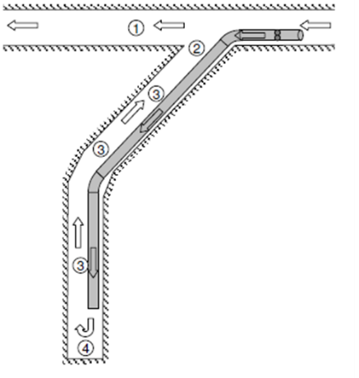

- Referring to the sketch:
- Test for O₂, CO₂, CO, NO_{x}, CH4 and take a dust sample / reading on the return air side of this development end, prior to re-entry (i.e. after the approved re-entry period, e.g. 30 min or whatever the re-entry period is.
- Accompanied by the developer, conduct the same tests as in 1. above, in the return air from the development end (i.e. in the development break-away). Record all measurements.
- If these gas readings are within the permissible quantities as per MH&SA Regulation 9.2 (1), proceed into the end, continuously testing for these gases and taking dust samples / readings at regular intervals, up to the blasted face. Record all these measurements.
- On the blasted face, check if the water blast is operating and test for all these gasses mentioned in 1. above, as well as taking dust samples / measurements. The “water-blast” must operate at least 15 minutes after the blast (regulation 9.2(1)).
- Tests for flammable gas on the face must be conducted on that part of the face, not covered with broken rock, as per standard practice (i.e. from footwall using the horizontal traverse method, up to against the hanging covering all face sockets).
- Compile a report and submit to the relevant people. It is important to note, that if the development end is not cleared within the approved re-entry period, from any of these gasses or Tyndallometer (dust measuring instrument) indicate unacceptable high dust concentrations, then a re-application for a revised re-entry period (longer re-entry period) must be submitted to the principal inspector for approval. The multi blast conditions for this end will then be void, and no multi-blast may continue until re-approval has been received from the Principal inspector.

- Question 2 (25)
  - Escape routes are an integral part of the mines escape strategy. State three requirements of escape routes. (3)
1) Displayed at the waiting place and all underground working places (1)
2) Reviewed / revised and updated on a regular basis (1)
3) Clearly demarcated with symbolic signs from the working place (1)

  - State seven of the main causes or sources of fires in underground mines. (7)
The main sources of fires in mines are:
1) Electrical sources
2) Frictional sources (scraper ropes, conveyor belts, etc.)
3) Blasting and incorrect use of igniter cord
4) Welding torches
5) Smoking or contraband
6) Diesel engines and fuel
7) Flammable fluid or greases
8) PVC or other similar materials
9) Impact generating sparks
10) Discharges of accumulations of static electricity

  - State three of the main causes of fires which are pertinent to collieries. (3)
Some causes which are pertinent to collieries are:
1) Coal dust explosions (1)
2) Spontaneous combustion (1)
3) Surface veld fires carried underground (1)

  - The cost of electricity will increase gradually to 85c per kW hour in 2018. (4)
2.4.1 Calculate the expected operating cost per annum for a 45 kW auxiliary fan. Assume the fan was operating for the full year.
2.4.2 Calculate the operating cost of the 45 kW fan for 1 m³/s per month. The fan duty is 12 m³/s at 1500 Pa.
Cost per annum = kW rated x (Cost rate x hours x days)
= 45 x (0.85 x 24 x 365) (1)
= 45 x 7446 = R 335 070.00 (1)
Cost of 1m³/s per month = Cost per annum / (Months x quantity)
= 335 070.00 / (12 x 12) (1)
= R 2 331.30 (1)

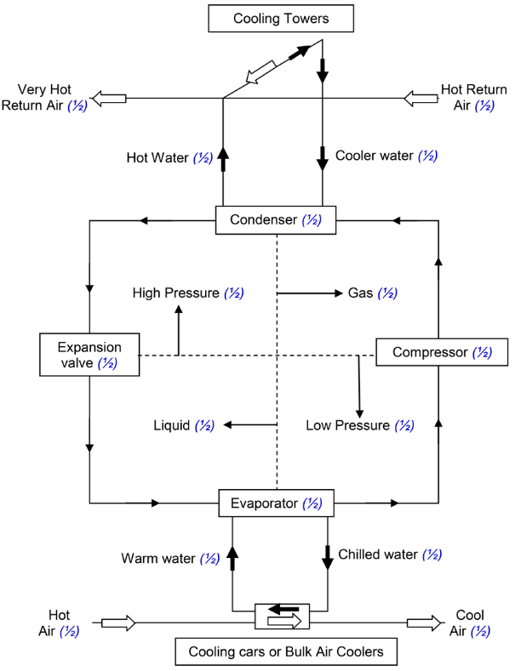
  - Sketch the complete Refrigeration cycle including the Hot water cycle to the cooling towers and the Cold Water cycle to the cooling cars or bulk air coolers. Show all the key components and indicate areas of high or low temperatures for air, water and refrigerant cycles. (8)

- Question 3 (20)
3.1 Give the definition of a refuge Bay. (2)
A refuge bay is a place underground in which workers can find refuge to escape the dangerous by-products of a mine fire or explosion for an undetermined period, (up to 24 hours) possibly until a rescue operation can be conducted.

3.2 Which factors must be considered before selecting a type of breathing apparatus? (8)
Distance to be travelled
Duration of the apparatus
Work space available
Size and weight of apparatus
Type of atmosphere with regards to toxicity and oxygen content
Restrictions that may have been imposed on the apparatus under the conditions of approval
After – sale service, maintenance and training.
Life-span (Rack life)

  - List the advantages and disadvantages of:
3.3.1Chemical Self Rescuer (6)
Advantages:
Generally a smaller unit.
Disadvantages:
Moisture affects the rack life of the unit.
High breath rate decreases the duration.
The chemical reaction generates heat.
Difficult to inspect.
Chemicals are expensive and hazardous.
3.3.2Pressurised Oxygen Type Self Rescuer (4)
Advantages:
Inhaled air is cool (not re-circulated).
It is reliable.
Easy to inspect.
Disadvantages:
Heavy and bulky.

- Question 4 (25)
  - The sketch below represents a network of airways with resistances given in Ns²/m⁸. Determine the total resistance for the whole network.

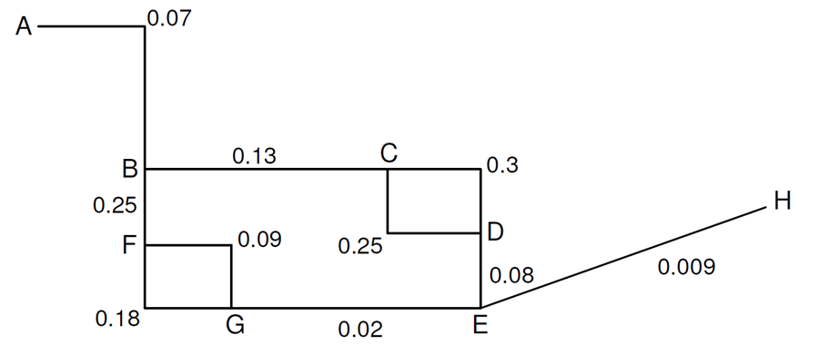

Parallel FG 1_ = 1____ + 1___
√Rfg √Rfg top √Rfg bot
= 1 + 1__
√0.09 √0.18
= 3.333 + 2.358
= 5.691
Rfg = (1 / 5.691)²
= 0.176²
= 0.0309 Ns²/m⁸ (2)

Series BE bot Rbfge = Rbf + Rfg + Rge
= 0.25 + 0.0309 + 0.02
= 0.3009 Ns²/m⁸ (1)

Parallel CD 1__ = ___ 1___ + 1___
√Rcd √Rcd top √Rcd bot
= 1 ___ + 1___
√0.25 √0.3
= 2 + 1.826
= 3.826
Rcd = (1 / 3.826)²
= 0.261²
= 0.0683 Ns²/m⁸ (2)

Series BE bot Rbcde = Rbc + Rcd + Rde
= 0.13 + 0.0683 + 0.08
= 0.2783 Ns²/m⁸ (1)

Parallel BE __1__ = 1___ + 1___
√Rbe √Rbe top √Rbe bot
= 1___ + 1___
0.2783 0.3009
= 1.896 + 1.823
= 3.719
Rbe = (1 / 3.719)²
= 0.269²
= 0.0723 Ns²/m⁸ (2)

Series AH Rah = Rab + Rbe + Reh
= 0.07 + 0.0723 + 0.09
= 0.1513 Ns²/m⁸ (1)

  - The pressure loss in an airway is 720 Pa with an airflow quantity 52.5m³/s and an air density of 1.058 kg/m³. Determine the area of the regulator to reduce the air quantity to 30 m³/s.

P2 = P1 x Q2²
Q1²
= 720 x 30²
52.5²
= 235 Pa (1)

Pressure to be destroyed by regulator = P1 – P2
= 720 – 235
= 485 Pa (1)

Area of regulator = 1.2 x Q x √ (w/p)
= 1.2 x 30 x √ (1.058 / 485)
= 1.68 m² (2)

  - A centrifugal exhaust fan will be installed in a 760mm diameter vent column. The column length will be 600m with a friction K factor of 0.0037 Ns²/m⁴. The fan will be operating at a density of 1.4 kg/m³.

4.3.1 Draw the fan performance curve and column resistance curve on the graph paper and determine the fan operating point. Show the table and all calculations in your exam book. (4)

4.3.2 New technology is available to use a HDPE column with a friction factor of 0.0015 Ns²/m⁴. Draw the new resistance curve and determine the new operating point. (4)

4.3.3 Comment on the stall characteristics of the fan and the most viable option to be taken (ignore cost of the installations). (2)

4.3.4 Comment on the fire precautions that must be in place at your mine for the HDPE column regarding fire spread and toxicity. (2)

Fan  Quantity  (m³/s) | Fan Pressure  (Pa)  W = 1.2 kg/m³ | Fan Pressure  (Pa)  W = 1.4 kg/m³ | Galvanised  Column  Resistance  Pressure (Pa) | HDPE  Column  Resistance  Pressure (Pa)
4 | 4800 | 5600 | 1057 | 429
6 | 4440 | 5180 | 2379 | 965
8 | 4620 | 5390 | 4230 | 1715
10 | 4280 | 4993 | 6609 | 2680
12 | 3500 | 4083 | 9518 | 3859
14 | 2200 | 2566 |  | 5252
16 | 20 | 23 |  | 6860
 |  | (2) | (1) | (1)

1. Density change
Q2 = Q1 x (W2 / W1)
= 4800 x (1.4 / 1.2)
= 5600 Pa (1)

Q2 = Q1 x (W2 / W1)
= 4440 x (1.4 / 1.2)
= 5180 Pa

Q2 = Q1 x (W2 / W1)
= 4620 x (1.4 / 1.2)
= 5390 Pa

Q2 = Q1 x (W2 / W1)
= 4280 x (1.4 / 1.2)
= 4993 Pa

Q2 = Q1 x (W2 / W1)
= 3500 x (1.4 / 1.2)
= 4083 Pa

Q2 = Q1 x (W2 / W1)
= 2200 x (1.4 / 1.2)
= 2566 Pa

Q2 = Q1 x (W2 / W1)
= 20 x (1.4 / 1.2)
= 23 Pa

2. Resistance for galvanised duct
R = KCL x W_
A³ 1.2
= 0.0037 x 2.388 x 600 x 1.4
(0.454)³ x 1.2
= 7.4219
0.1123
= 66.095 Ns²/m⁸ (1)
P = RQ²
= 66.095 x (4)²
= 1057 Pa

P = RQ²
= 66.095 x (6)²
= 2379.42 Pa

P = RQ²
= 66.095 x (8)²
= 4230.08 Pa

P = RQ²
= 66.095 x (10)²
= 6609.5 Pa

P = RQ²
= 66.095 x (12)²
= 9517.68 Pa

Resistance for HDPE duct
R = KCL x W
A³ 1.2
= 0.0015 x 2.388 x 600 x 1.4
(0.454)³ x 1.2
= 3.0089
0.1123
= 26.795 Ns²/m⁸ (1)

P = RQ²
= 26.795 x (4)²
= 714.5 Pa

P = RQ²
= 26.795 x (6)²
= 964.6 Pa

P = RQ²
= 26.795 x (8)²
= 1714.9 Pa

P = RQ²
= 26.795 x (10)²
= 2679.5 Pa

P = RQ²
= 26.795 x (12)²
= 3858.5 Pa

3. The fan will be operating very close to the stall zone (when the pressure and volume of the fan decreases) (1)
Running a fan in this area of the performance curve may result in high strain on the fan components. Opting for a lower resistance ducting will be a suitable alternative (1)

4. The fire precautions for all PVC (plastic) related products require that the products must be flame retardant (i.e. self-extinguished once flame is removed) (1) and the toxicity index from the gases given of during testing in an accredited lab must be below an index of 5 (may be less for some mining groups) (1)

